No Increase in Wettest Days
Submission to the NSW Flood Inquiry
By Jennifer Marohasy and Chris Gillham

SUMMARY

Torrential rains along the east coast of Australia during February and March 2022 have been blamed on climate change. Specifically, a narrative has developed suggesting that rainfall is becoming more extreme.

“The pattern of more intense rainfall events is well established in Australia. In recent decades, the intensity of short duration (hourly) extreme rainfall events has increased by 10 percent. The intense rainfall and floods devastating communities in Queensland and New South Wales is taking place in an atmosphere made warmer and wetter by climate change, which is driven by the burning of coal, oil, and gas. Climate Council, March 2022

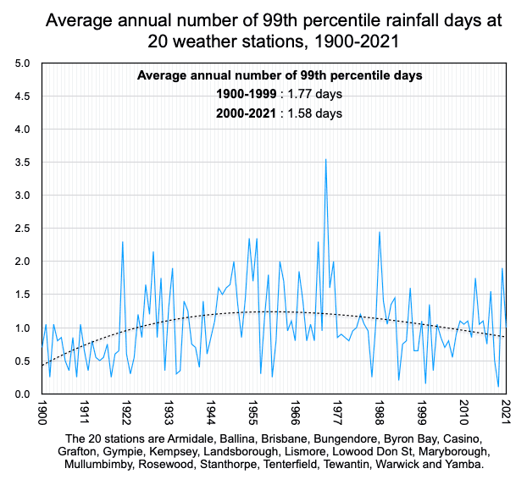
Analysis of the 20 longest rainfall records in the 2022 flood zone does not, however, support this claim. There has been no overall increase in the intensity or frequency of extremely wet days. The wettest year, measured as the year with the highest number of 99th percentile rainfall days since 1900, is 1974.

The amount of rain falling on these wettest days also peaked in 1974, when measured as total rainfall since 1900. Some locations measured wettest days in the late 1800s, but not all locations had weather stations operating at that time, so we begin averaging from 1900. Mullumbimby, for example, did not begin measuring daily rainfall until 1899.

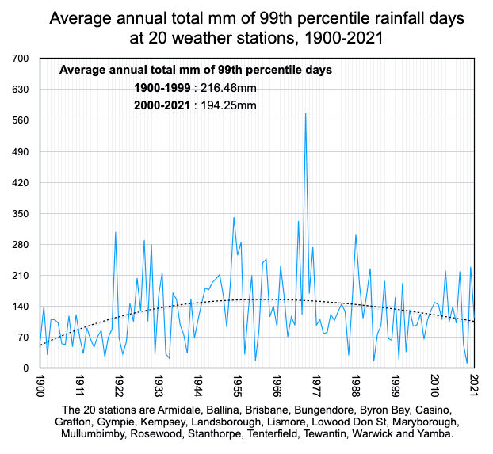

Only four locations – Mullumbimby, Rosewood, Yamba and Lowood – recorded their highest ever 24-hour rainfall totals in 2022. It will be interesting to understand how 2022 compares with other years when all the data for this year has been compiled and averaged.

The Australian 24-hour rainfall record of 907mm is still Crohamhurst in the Brisbane catchment recorded on 3rd February 1893. We will never know how much rain fell at Crohamhurst in February 2022 because that weather station (#040062) was closed by the Australian Bureau of Meteorology (BoM) in March 2003.

METHOD

A search of the Australian Data Archive for Meteorology (ADAM) was undertaken to find the highest daily rainfall total. A search of this same dataset was undertaken to find locations in the flood affected regions with continuous daily rainfall records that begin before 1900. These locations are Armidale, Ballina, Brisbane, Bungendore, Byron Bay, Casino, Grafton, Gympie, Kempsey, Landsborough, Lismore, Lowood, Maryborough, Mullumbimby, Rosewood, Stanthorpe, Tenterfield, Tewantin, Warwick and Yamba.

Locations with more than one weather station were combined. For example, the Lismore record from Centre Street (#058037) was combined with the Lismore record from the airport to create the longest possible continuous record to the present.

To understand trends in the intensity and frequency of daily rainfall at each of the 20 locations, all days with 0 mm of rainfall were deleted and the remaining days with rainfall were sorted descending from the wettest to those with just 0.1mm of rainfall. The 99th percentile rainfall days were calculated by estimating the lowest mm total within the top 1% of such days.

These calculations were assisted through use of the percentile function in the Numbers spreadsheet program using an Apple Mac computer. Comparison of the spreadsheet function with manual percentage calculations had consistently identical results. All days since 1 January of each station's beginning year, with or without rainfall, were pasted into a calculation spreadsheet with five different functions:

- a count each year of all days with more than 0mm of rainfall
- the sum each year of total mm of rainfall
- a count each year of all days with equal to or more than the 99th percentile previously calculated
- the sum each year of total mm of rainfall days falling within the 99th percentiles
- The resulting columns of annual data for each of the 20 stations were then collectively averaged from 1900 – 2021, because all 20 locations have continuous records during that period.

RESULTS & DISCUSSION

The location of Crohamhurst in the Brisbane catchment holds the 24-hour record for the wettest ever day with 907 mm recorded on 3rd February 1893. This is still the highest one-day rainfall total for anywhere in Australia. We will never know if this record was exceeded in February 2022 because the Bureau has closed the Crohamhurst weather station. It was closed in March 2003 and is therefore not one of our 20 longest rainfall records. Peachester (#40169), just 2.8km away, had a peak daily rainfall of 305.0mm on 26 February 2022 – less than its record of 365.0 mm on 9 February 1999.

The BoM in its monthly summary for February 2022 claimed a new 24-hour record for Lismore of 146.8 mm from the Lismore airport. This airport weather station, however, only began recording rainfall data in 2003, replacing the Centre Street weather station. Joining the Centre Street and airport rainfall records into a single series, the wettest day on record at Lismore is still 21st February 1954 when 334.3 mm fell. It is important to join up the records for the one location. Otherwise, spurious records can be claimed based on very short time periods.

Considering the entire record, only four of these 20 longest weather stations recorded their highest ever 24-hour rainfall totals this year, in 2022. These locations are Mullumbimby, Rosewood, Yamba and Lowood (Don Street). A total of 240 mm fell on Saturday 26th February 2022 at Lowood, which was a record for the location for any one day since August 1887 when they began measuring daily rainfall at Lowood. Except there are not records for Lowood for the few days in February 1893 when there was flooding. It is likely that the rainfall gauge at Lowood was washed away back in February 1893. The wettest day on record at several of the 20 weather stations with the longest rainfall record occurred in the late 1800s, with 1893 particularly wet at Armidale and Landsborough.

The late 1800s included some particularly wet years. Other wet years include 1956 and 1974.

By only considering the last few decades of rainfall at any one site and ignoring the long history of droughts and floods, it is possible to wrongly conclude that the intensity of rainfall is increasing.

The annual number of days above the 99th percentile (the wettest 1% of days) and the total volume of rainfall falling on these days are measures of frequency and intensity. If these valid measures do not show a consistent increase over the period of the rainfall record, then it is simply not logical to conclude that the intensity of rainfall is increasing whether due to climate change or any other cause.

Armidale

February 2022 highest daily rainfall: 20.2mm
March 2022 highest daily rainfall: 32.8mm
February highest daily rainfall ever: 113.6mm in 1977
March highest daily rainfall ever: 106.2mm in 1893

Armidale has an exceptionally long rainfall record beginning in 1872. In 1879 there were five wettest days when the rainfall exceeded 47.2 mm (total 326.2 mm). There were only four wettest days in 1949 but a higher total amount of rain fell on those days (369.9 mm).

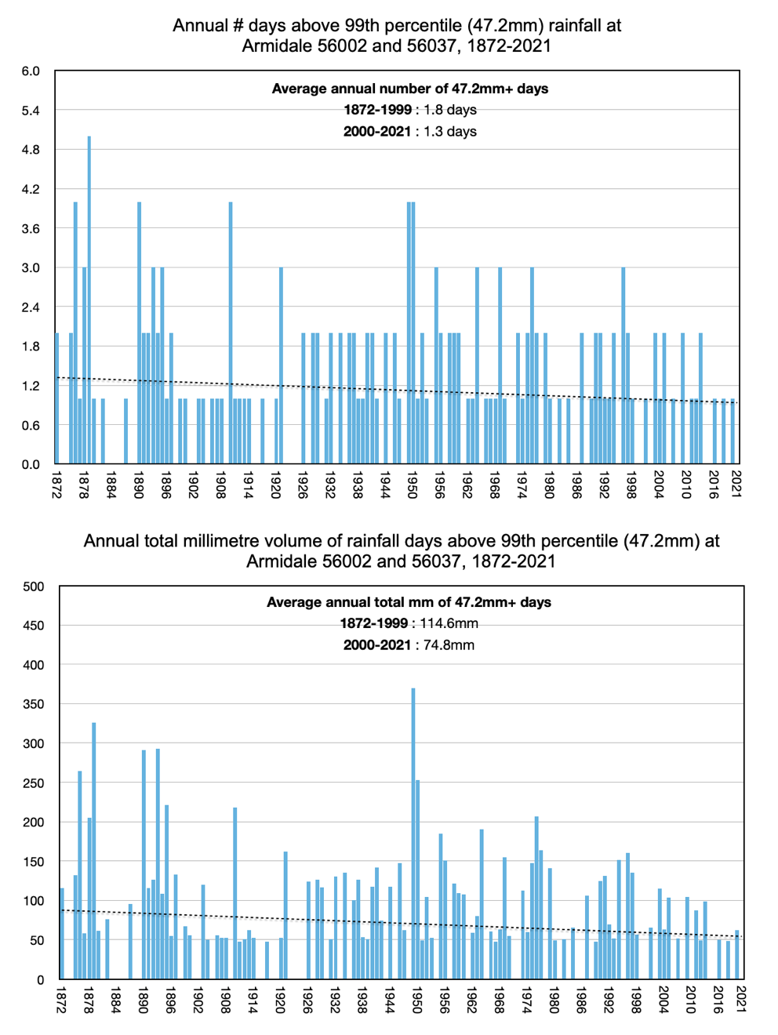

Ballina

February 2022 highest daily rainfall: 195.4mm
March 2022 highest daily rainfall: 282.0mm
February highest daily rainfall ever: 264.2mm in 1954
March highest daily rainfall ever: 374.0mm in 1974

Ballina has a very long rainfall record beginning in 1893. Only 1 percent of days have had rainfall that exceeds 107mm. In 1962, there were seven days when more than 107 mms fell. Since 1962 the number of extremely wet days each year has been declining. It will be interesting to know the number of wet days that exceed 107 mm when this year (2022) is ended.
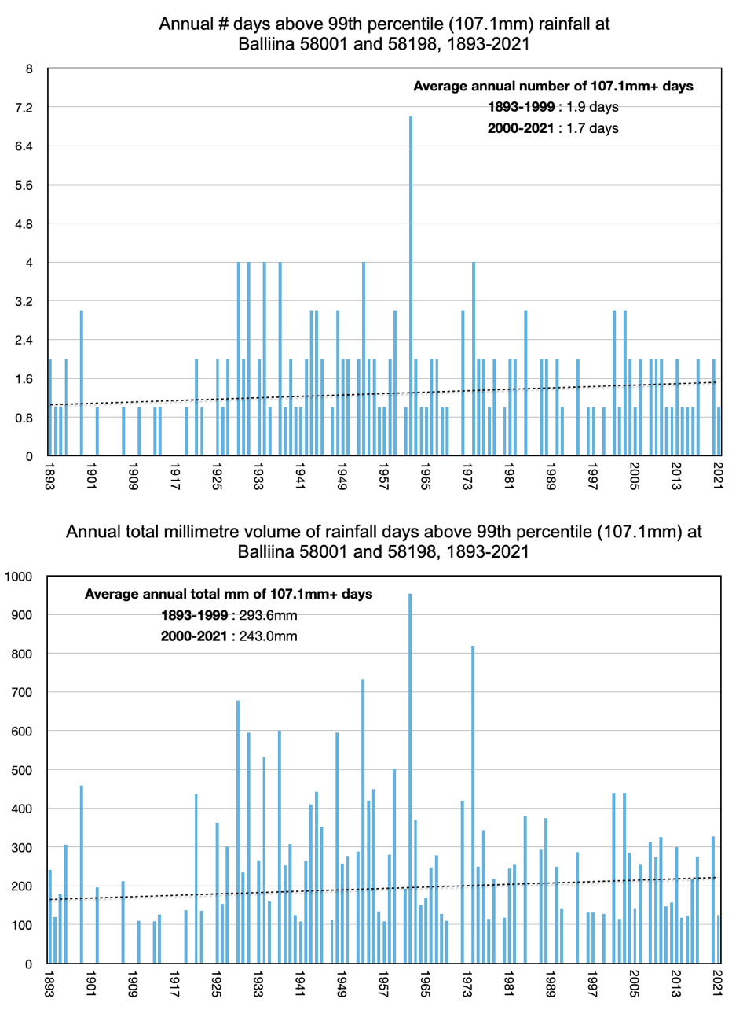

Brisbane

February 2022 highest daily: 228.4mm
March 2022 highest daily: 63.8mm
February highest daily ever: 269.5mm in 1931
March highest daily ever: 284.0mm in 1908

The wettest years in Brisbane were in the late 1800s and early 1970s. In 1893 there were seven days when more than 89 mm of rain fell. In 1974 there were five days. In 1996, 776 mm fell across four days, giving an average of 194 mm each day.
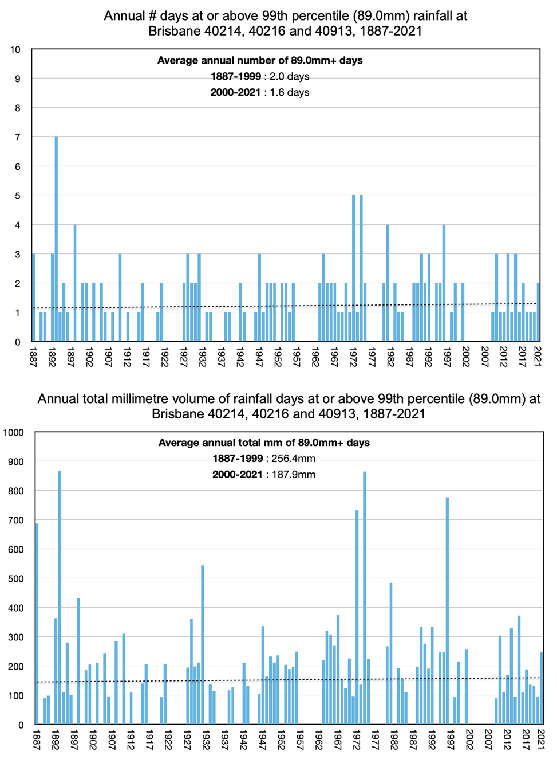

Bungendore

February 2022 highest daily rainfall: 28.4mm
March 2022 highest daily rainfall: 42.0mm
February highest daily rainfall ever: 84.4mm in 2010
March highest daily rainfall ever: 129.0mm in 1989

Bungendore is a town to the southwest of Sydney with an exceptionally long rainfall record that begins in 1886. Only 1 percent of days over the period 1886 to 2021 have exceeded 47 mm of rainfall. In 1974 there were more than 5 days in this 99th percentile, and over these five days more than 339 mm of rain fell.
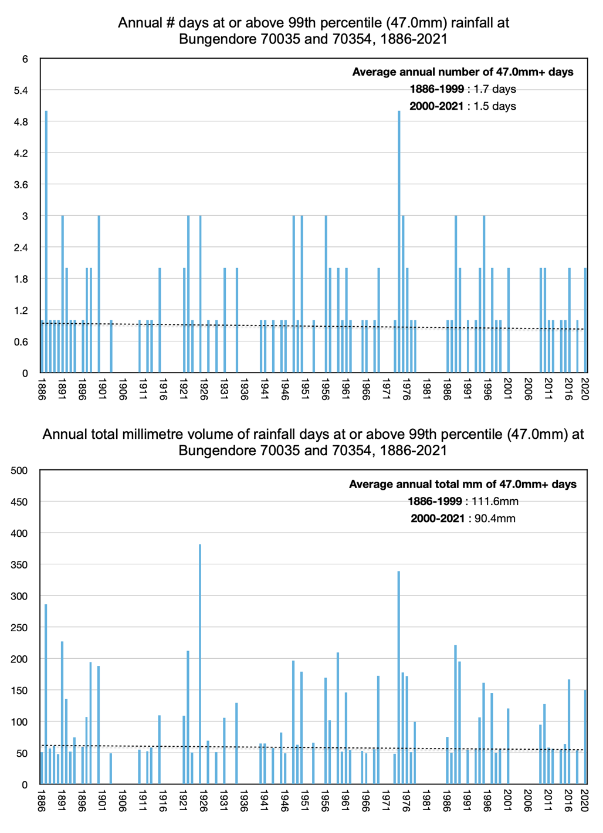

Byron Bay

Feb 2022 highest daily: 155.0mm
Mar 2022 highest daily: 268.2mm
February highest daily ever: 309.8mm in 2001
March highest daily ever: 296.3mm in 1991

Considering the number of days each year above 125 mm since 1893, and, also, the total volume of rain falling during these days, 1974 was the wettest year on record at Byron Bay.
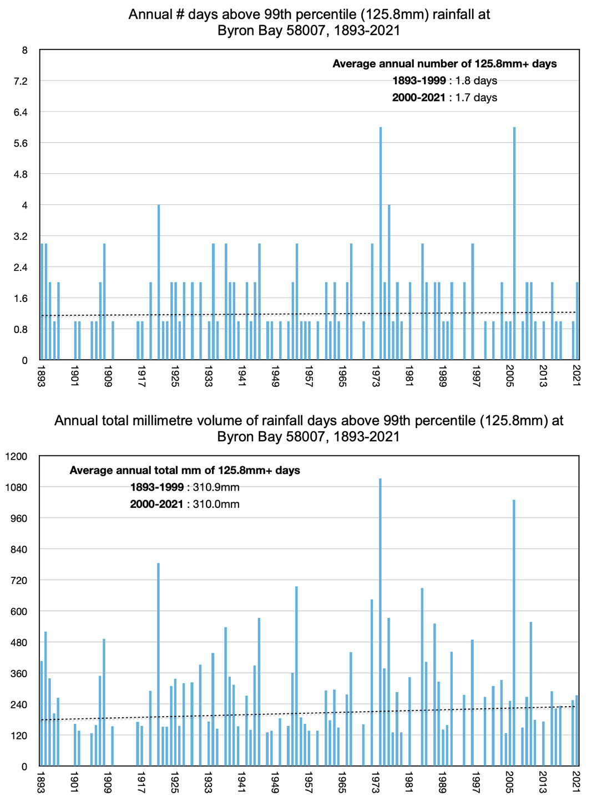

Casino

February 2022 highest daily rainfall: 240.2mm
March 2022 highest daily rainfall: 88.4mm
February highest daily rainfall ever: 267.2mm in 1954
March highest daily rainfall ever: 248.4mm in 1987

The rainfall record for Casino begins in 1880. The wettest 1 percent of days have had rainfall that exceeds 80.8 mm – considering the period 1880 to 2021. In 1946 there were five of these very wet days with a total of 488 mm of rain falling over the five days.
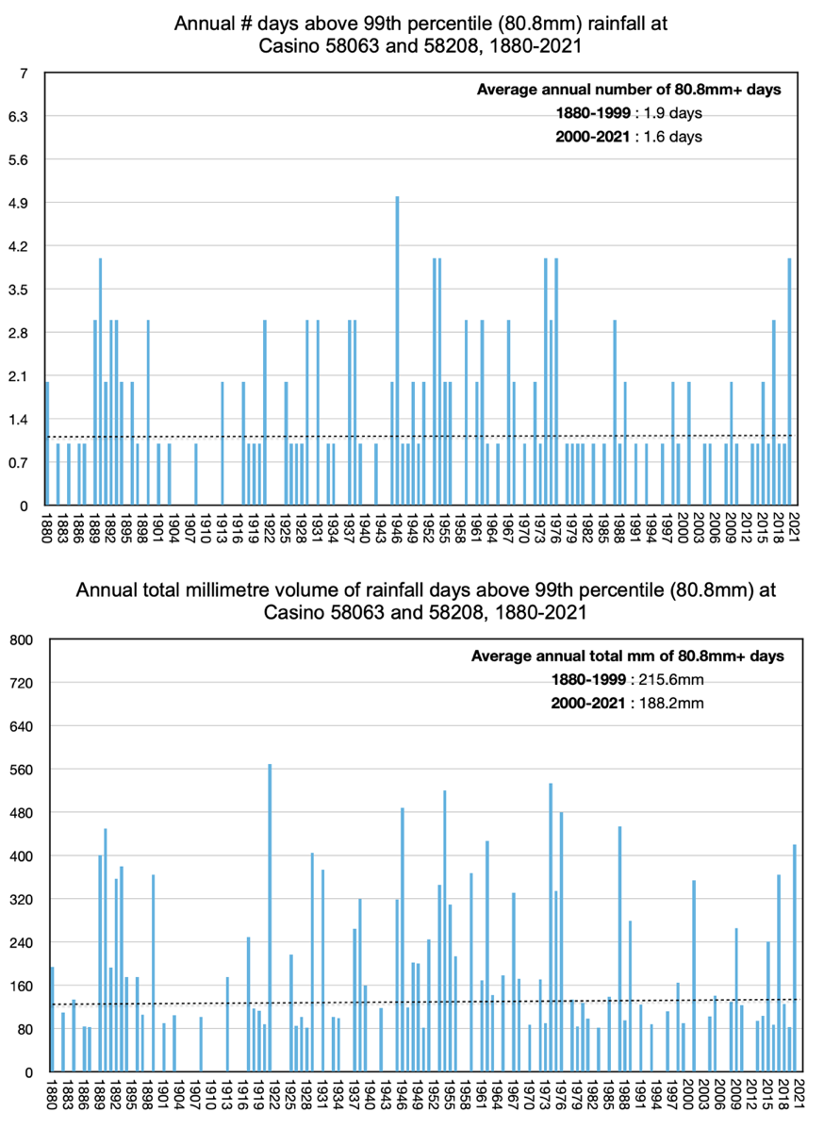

Grafton

February 2022 highest daily rainfall: 252.0mm
March 2022 highest daily rainfall: 94.4mm
February highest daily rainfall ever: 246.4mm in 1954
March highest daily rainfall ever: 274.3mm in 1974

The trend of increasing wettest days at Grafton is the result of the record number of wettest days in 2020: seven days above 80 mm giving a total rainfall of 696.2. There were five wettest days in 1974 giving a total rainfall of 767.2 mm.
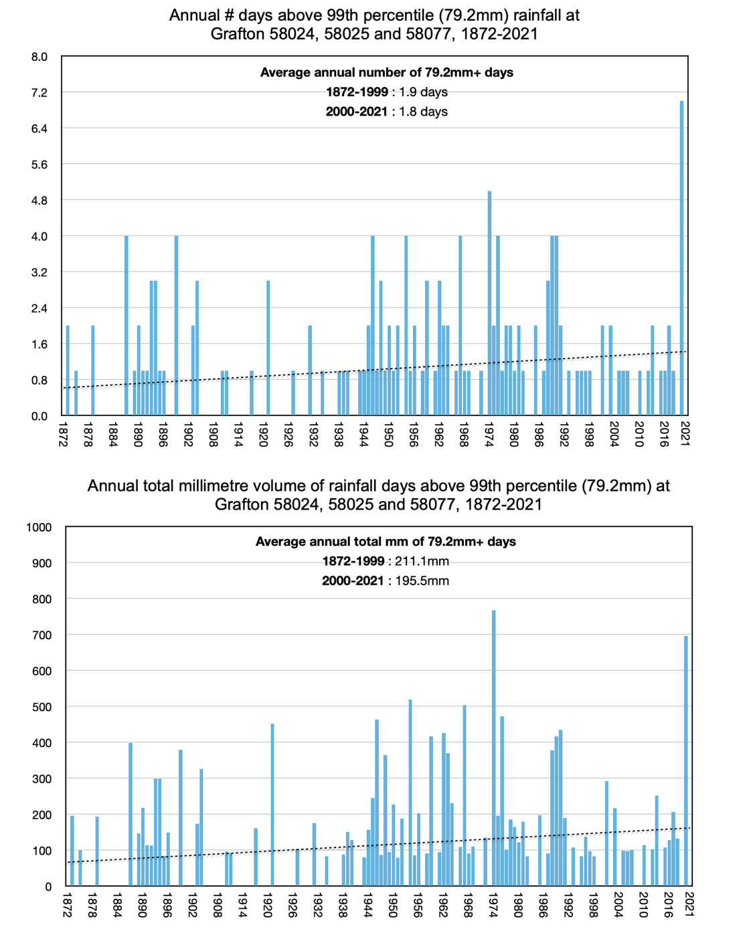

Gympie

February 2022 highest daily rainfall: 206.4mm
March 2022 highest daily rainfall: 49.2mm
February highest daily rainfall ever: 336.0mm in 1992
March highest daily rainfall ever: 295.7mm in 1901

Rainfall at Gympie has been recorded at the one weather station since 1888. The year 1893 was exceptionally wet in southeast Queensland, including at Gympie. In that year, 1043 mm of rain fell over just seven days. Rainfall has not been so intense since but it will be interesting to see whether any records are broken this year, 2022.
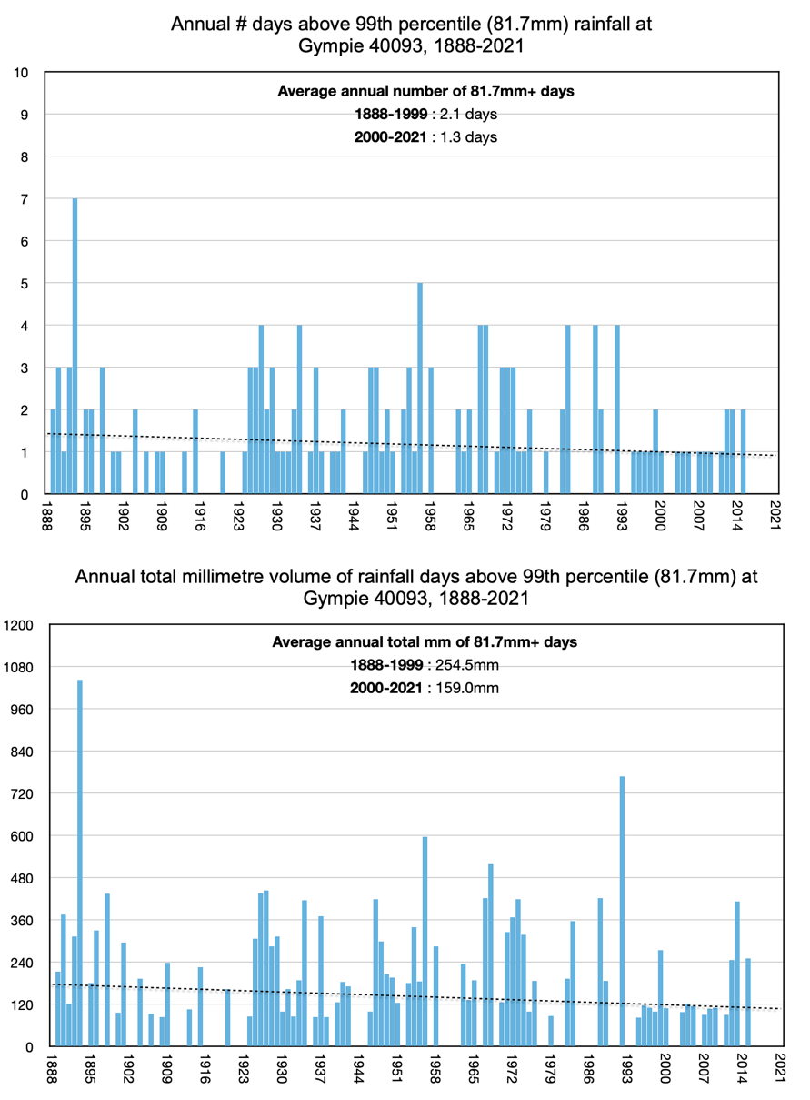

Kempsey

February 2022 highest daily rainfall: 50.4mm
March 2022 highest daily rainfall: 113.6mm
February highest daily rainfall ever: 263.1mm in 1929
March highest daily rainfall ever: 267.1mm in 1974

Kempsey has a continuous rainfall record beginning in 1882. Interestingly, the wettest year measured in terms of number of days (6) recording more than 97 mm and the total amount of rain falling on these days (826 mm) is 1933 – this is not a year usually associated with extreme rainfall. The next year with several days (5) exceeding 97 mm at Kempsey is 1974, which was a wet year at many other locations along the east coast of Australia.
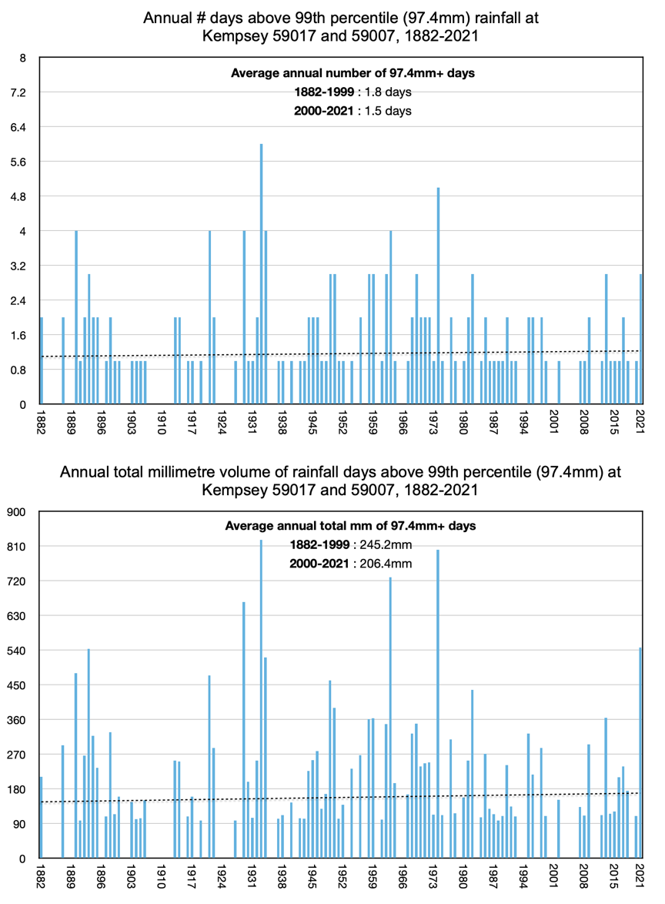

Landsborough

February 2022 highest daily rainfall: 345.0mm
March 2022 highest daily rainfall: 68.4mm
February highest daily rainfall ever: 638.8mm in 1893
March highest daily rainfall ever: 262.9mm in 1898

At Landsborough the 1 percent of wettest days since records began in 1893 have received 132.6 mm of rain. In 1974 there were five of these wettest days with a total rainfall of 1018 mm. The very wettest year measured in terms of number of days exceeding this 99th percentile (132.6 mm) is 1893, which was a very wet year.
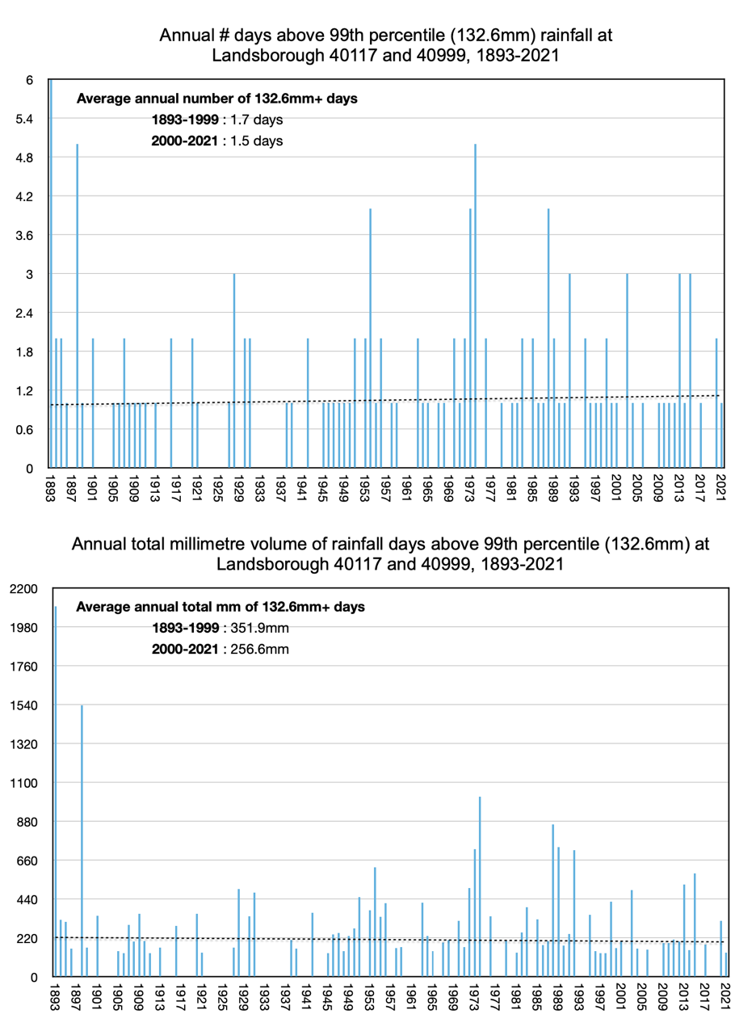

Lismore

February 2022 highest daily rainfall: 146.8mm
March 2022 highest daily rainfall: 31.0mm
February highest daily rainfall ever: 334.3mm in 1954
March highest daily rainfall ever: 246.3mm in 1974

The terrible flooding that occurred in Lismore this year (2022) made national and international headlines often accompanied by claims it was caused by climate change, specifically more and more intense rainfall. The Australian Bureau of Meteorology even claimed a new record wet day for Lismore on the 24th February 2022 of 146.8 mm. The claimed new record was an artefact of the Bureau beginning the rainfall record for Lismore in 2003, when the official weather station was moved to the airport. The wettest day on record, considering the entire record that begins in 1885, is still 21st February 1954. The wettest year on record in terms of total rainfall is still 1893. The wettest 1 percent of days over the period 1893 to 2021 had rainfall totals of more than 85 mm. Linear regression indicates that there has been no increase in the number of these wettest days.
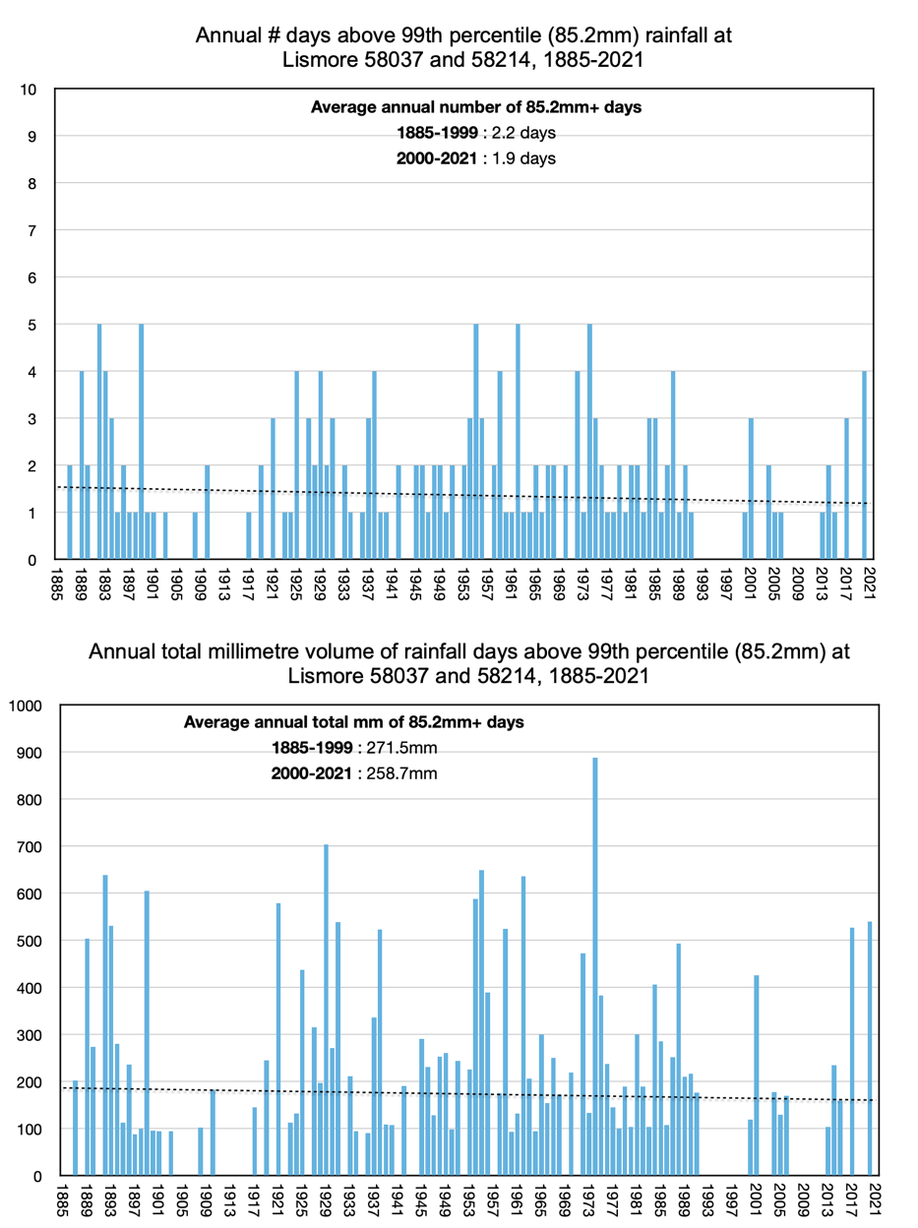

Lowood (Don St)

February 2022 highest daily rainfall: 240.0mm
March 2022 highest daily rainfall: 26.0mm
February highest daily rainfall ever: 240.0mm in 2022
March highest daily rainfall ever: 181.1mm in 1908

Lowood is not far from Crohamhurst, which holds the record for the wettest day ever recorded in Australia on 3rd February 1893. There is a long rainfall record for Lowood beginning in 1888, but there were no recordings made through February 1893. It is possible the rainfall was so intense it swept the Lowood rain gauge away. With this missing rainfall data, 26th February 2022 now holds the record for the wettest day at Lowood. The wettest 1 percent of days that have been recorded have had more than 74 mm. There were four days that fall into this category back in 1890. Interestingly, 1988 was also a year with some (4) intensely wet days at Lowood.
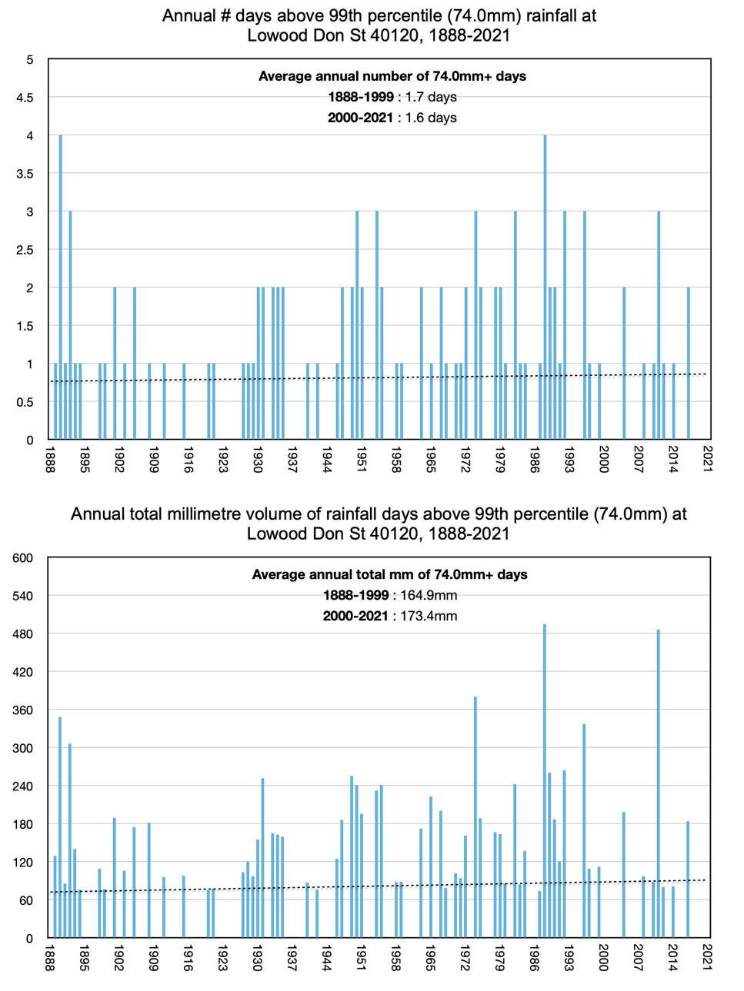

Maryborough

February 2022 highest daily rainfall: 92.6mm
March 2022 highest daily rainfall: 25.4mm
February highest daily rainfall ever: 359.9mm in 1931
March highest daily rainfall ever: 344.4mm in 1952

At Maryborough, 1893 is the year of most intense rainfall measured in terms of number of days above the 99th percentile (85.6 mm), and also the year with the highest annual total volume of rainfall days above the 99th percentile (1027 mm).
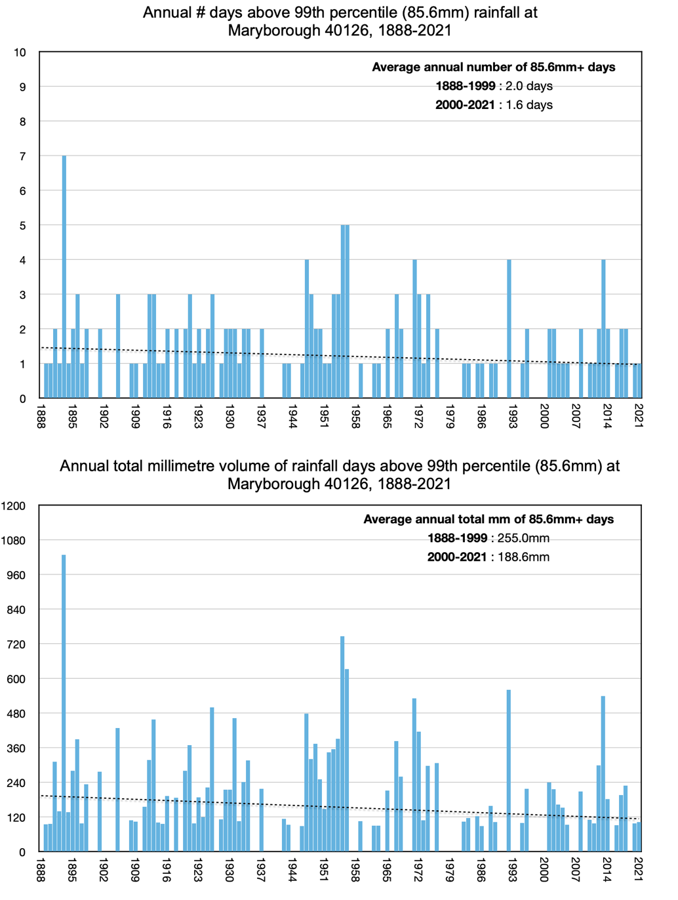

Mullumbimby

February 2022 highest daily rainfall: 520.0mm
March 2022 highest daily rainfall: 206.0mm
February highest daily rainfall ever: 520.0mm in 2022
March highest daily rainfall ever: 362.0mm in 2017

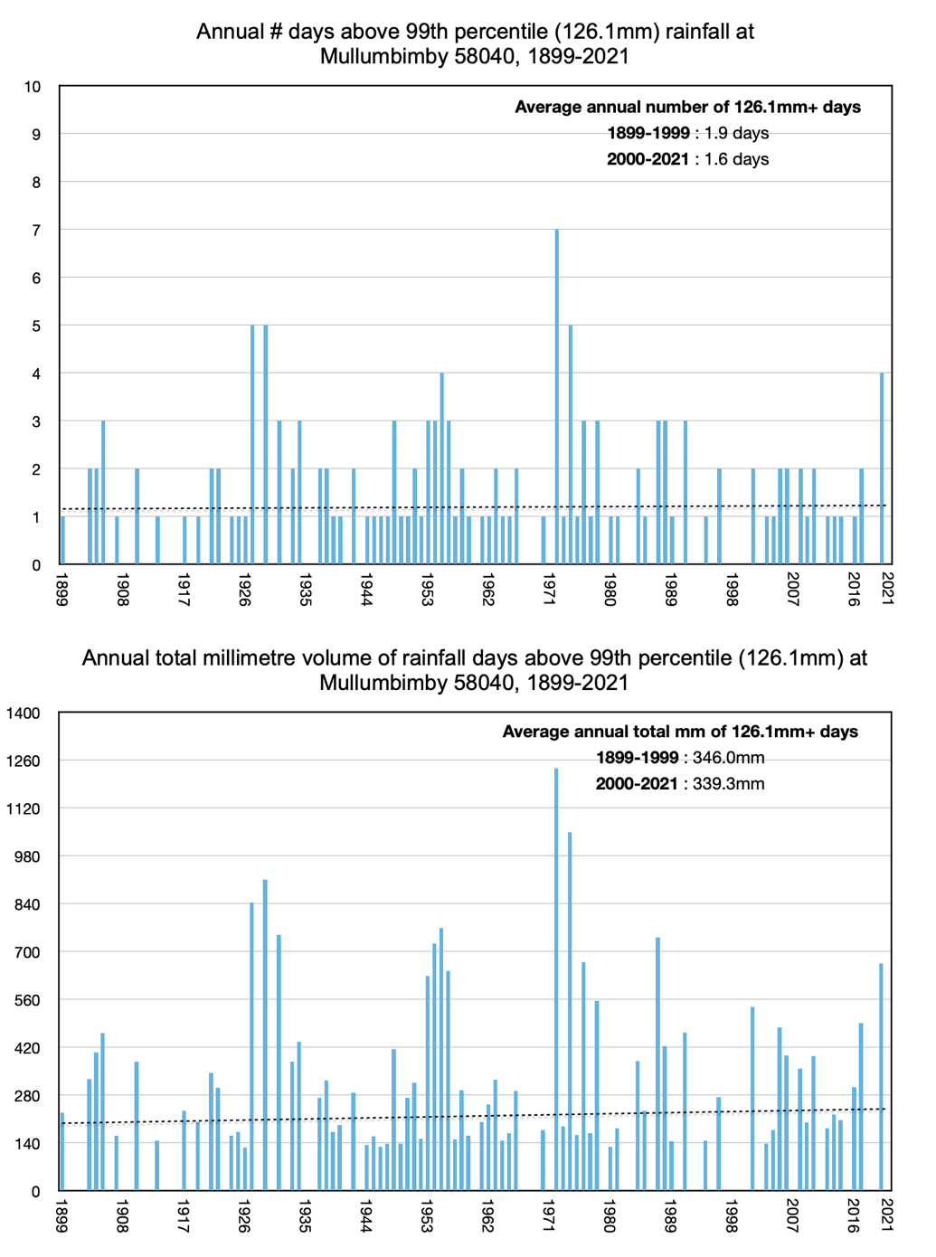
On the wettest days in Mullumbimby more than 126 mm of rain falls. There were five of these wettest days in 1974, and the cumulative total for the five days was 1048 mm. It was wet again in Mullumbimby this year with 520 mm falling on 28th February, making it the wettest February on record since rainfall was recorded at Mullumbimby beginning in 1899.

Rosewood

February 2022 highest daily rainfall: 222.0mm
March 2022 highest daily rainfall: 40.0mm
February highest daily rainfall ever: 222.0mm in 2022
March highest daily rainfall ever: 236.2mm in 1908

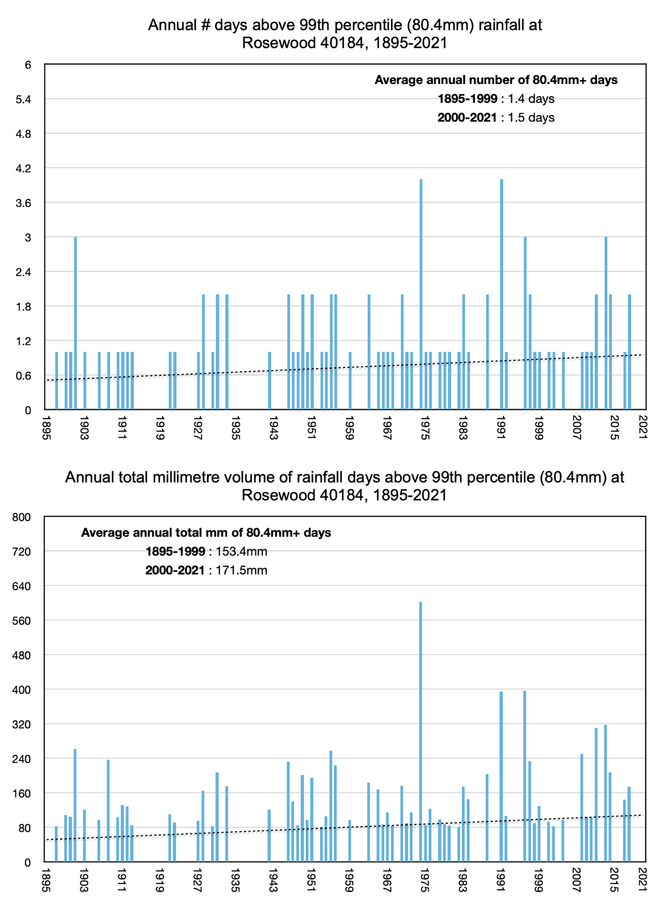
There has been a slight increase in the number of wettest days each year at Rosewood, considering the period 1895 to 2021. There were four days in 1974 when more than 80 mm of rain fell, and the cumulative total was 602 mm. This was the year of most intense rainfall at Rosewood.

Stanthorpe

February 2022 highest daily rainfall: 39.8mm
March 2022 highest daily rainfall: 28.9mm
February highest daily rainfall ever: 199.0mm in 1976
March highest daily rainfall ever: 157.5mm in 1897

The Stanthorpe daily rainfall records begin in 1888 and show a high frequency of 99th percentile days prior to 1900 with a marked decline thereafter. Average annual frequency of extremely wet days peaked in the 1980s at 1.2 (average volume 55.6 mm) and from 2012 to 2021 averaged 1.0 (average volume 35.7 mm).
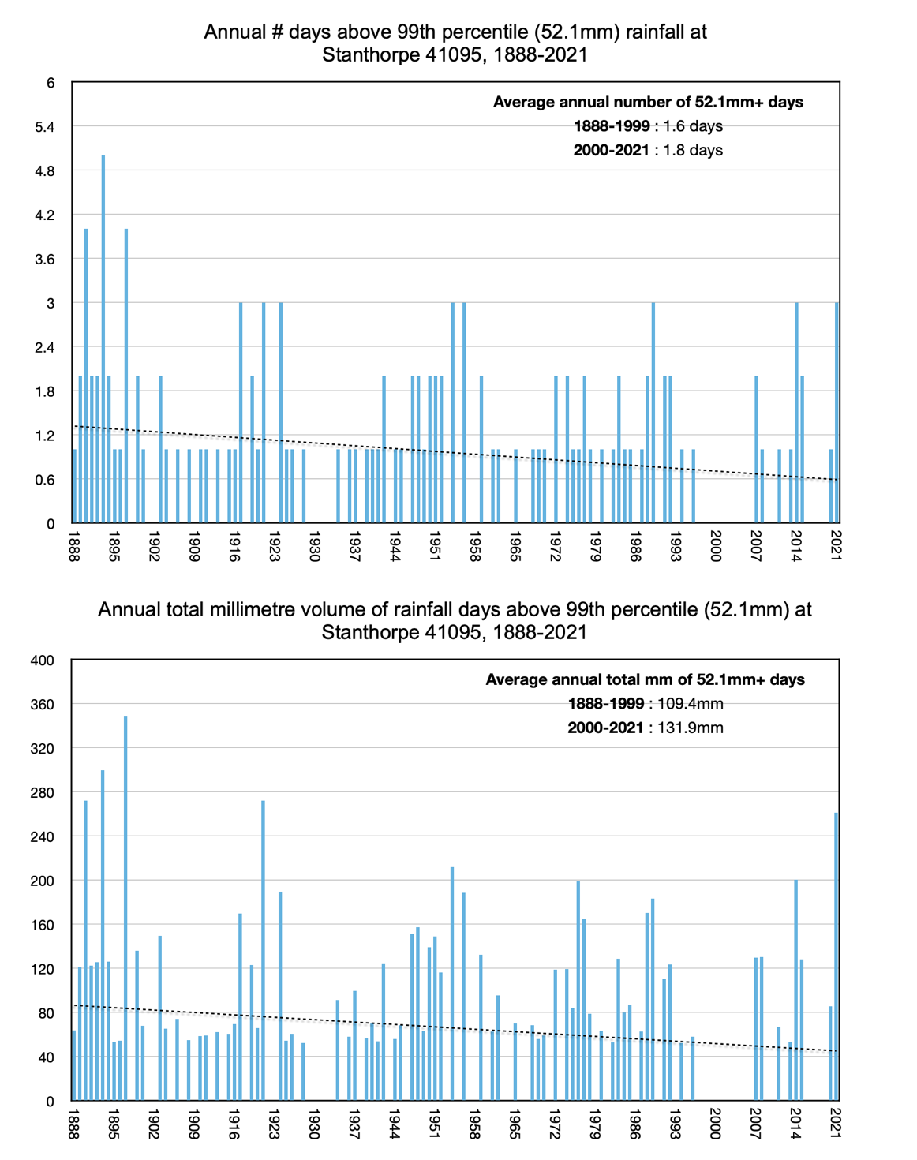

Tenterfield

February 2022 highest daily rainfall: 20.2mm
March 2022 highest daily rainfall: 47.2mm
February highest daily rainfall ever: 190.6mm in 1976
March highest daily rainfall ever: 139.7mm in 1897

Tenterfield is inland from Ballina. In 1962 there were seven days when more than 107 mm fell at Ballina, making this the year with the most extremely wet days. The wettest days in Tenterfield are only about half as wet (55 mm) as the wettest days in Ballina but interestingly the wettest days were also in 1962.
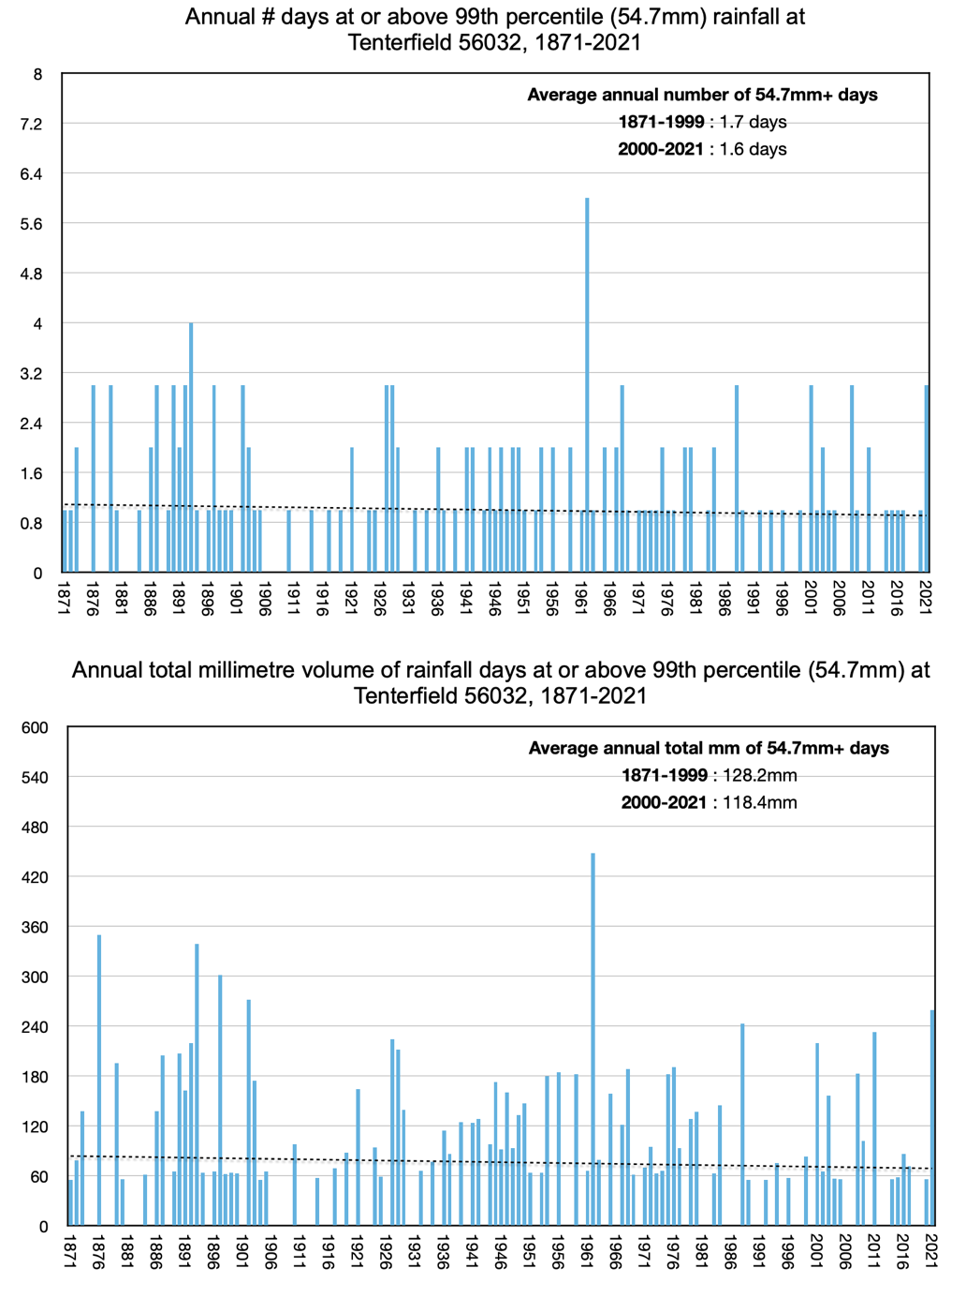

Tewantin

February 2022 highest daily rainfall: 369.2mm
March 2022 highest daily rainfall: 60.4mm
February highest daily rainfall ever: 732.0mm in 1992
March highest daily rainfall ever: 312.4mm in 1904

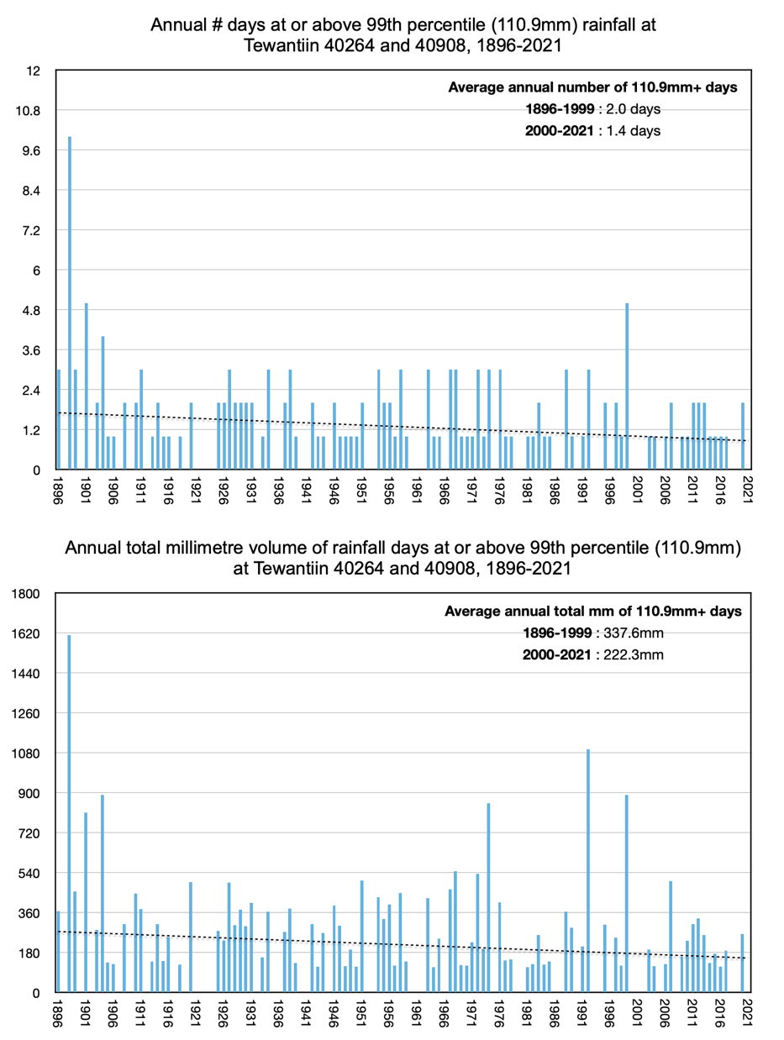
On a wettest day at Tewantin 110.9 mm falls. Back in 1898 there were 10 very wet days. Because there were so many wettest days so long ago, the overall linear trend at Tewantin suggests that rainfall is now less intense than it was more than 100 years ago.

Warwick

February 2022 highest daily rainfall: 31.0mm
March 2022 highest daily rainfall: 32.0mm
February highest daily rainfall ever: 195.3mm in 1890
March highest daily rainfall ever: 101.6mm in 1939

There is a long rainfall record for Warwick beginning in 1888 that suggests an ever so slight increase in the number of wettest days, and also in the total amount of rain falling on those wettest days. It is often the case that Warwick has two wettest days in a year. In 2021 the two wettest days gave a rainfall total of 170.6 mm.

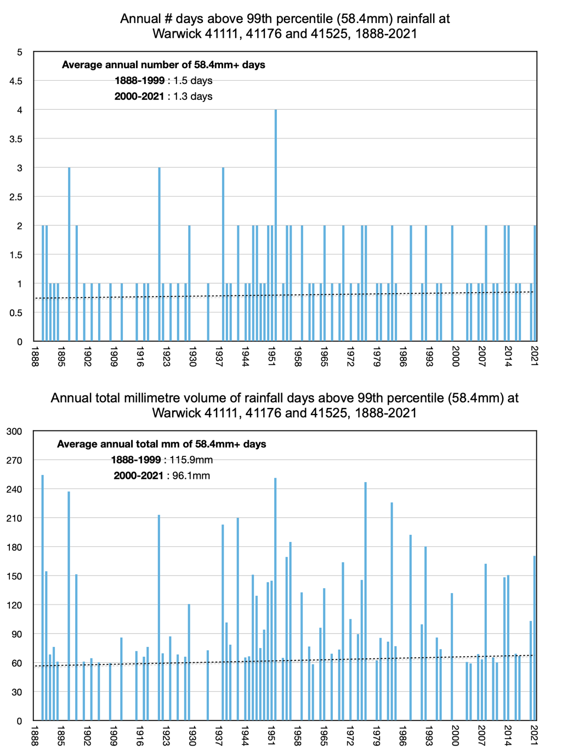

Yamba

February 2022 highest daily rainfall: 274.4mm
March 2022 highest daily rainfall: 258.2mm
February highest daily rainfall ever: 274.4mm in 2022
March highest daily rainfall ever: 300mm in 1999

The overall trend at Yamba is one of wetter days since records began back in 1878. The average annual number of 99th percentile days was 2.7 in 1958-1967 (average annual volume 319.5 mm) and 1.5 in 2012-2021 (average annual volume 196.6 mm). The highest daily total rainfall ever recorded was this year on 28th February 2022 when 274.4 mm fell on the one day. In 2021 there was only one wettest day, and on that day 114.6 mm fell.
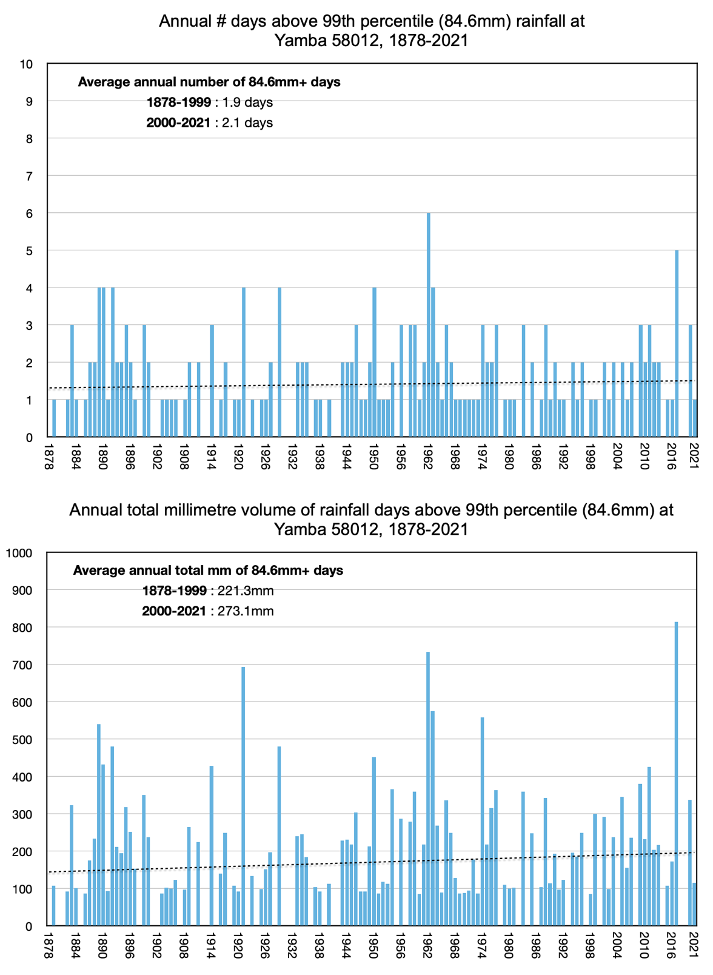

Acknowledgements

This report was funded by the B. Macfie Family Foundation through the Institute of Public Affairs.

The Australian Data Archive for Meteorology (ADAM), which was the source of all daily rainfall data, can be accessed online at http://www.bom.gov.au/climate/data/ .

